Peer-to-Peer Mentoring Handbook
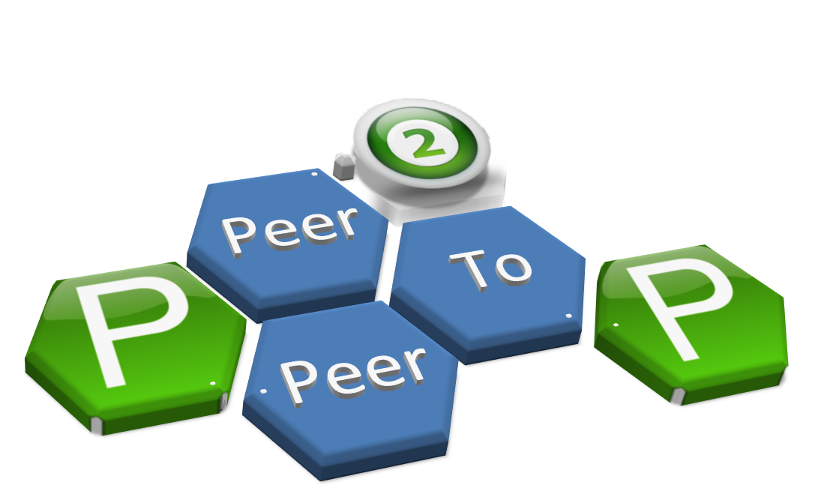

Published by the Peer-to-Peer Mentoring Committee and the Graduate School of Education

2015-2016
Adapted from the Washington University Graduate Student Peer Mentoring Handbook
Table of Contents

Vision Statement 3

Mission Statement 3

The Role of a Peer Mentor 4

Examples of Ways to Create a Successful Peer Mentoring Program 6

Examples of Peer Mentoring Projects and Activities 7

Questions Frequently Asked by Peer Mentors 9

Questions Frequently Asked by Mentees 11

Resources 12

References 14

Vision Statement

The Peer-to-Peer Mentoring Program (P2P) will provide support, encouragement, and resources to first-year doctoral students in the Educational Policy, Planning & Leadership (EPPL) program in the School of Education at the College of William and Mary for our peers to achieve academic, social, and professional success.

Mission Statement

In the interest of the development and advancement of K-12 and Higher Education scholarship, we are a group of current doctoral students in the School of Education (SOE) at the College of William and Mary who will serve as peer mentors for first-year doctoral students (FYDS). This program is the first of its kind in the SOE focusing on FYDS. A student-led committee comprised of members representing all five program areas within EPPL will share the responsibility of connecting peer mentors with peer mentees.

Peer mentors are:
- at a minimum in their second year of doctoral work in the EPPL program
- serve as a point of contact for peer mentees
- are resources for peer mentees
- are not academic advisors or professional counselors

Peer mentees are:
- in their first year of doctoral work in the EPPL program
- interested in connecting with other EPPL students, other SOE students, and the faculty and staff in the SOE and the College of William and Mary

We seek to support FYDS academically, socially, and professionally through mutual respect while understanding that we are peers and we are here to support each other. We will help answer our peers’ questions and/or guide them to appropriate resources. Peer mentors will engage in one-to-one pairings with FYDS; purposeful networking events with current students, faculty, staff, and alumni; social events with other student organizations; and guidance in making connections with other resources within the SOE and the College of William and Mary.

The Role of a Peer Mentor

Program Structure
The P2P Committee, supported by the Graduate School of Education and advised by Dr. Megan Tschannen-Moran, exists to support FYDS in the EPPL programs through peer-to-peer matching, peer mentor training, student involvement, and event planning. The P2P Committee consists of students from all five EPPL program areas. The Committee and all peer mentors from the EPPL programs form a network of students who are able to help guide one another. All students who participate in the P2P program are encouraged to network within and beyond EPPL as well as seek out assistance from their department chair in order to increase the awareness of the P2P program.

What is a peer mentor?
A peer mentor is a fellow student who is a doctoral student in at least his/her second year of an EPPL program. A peer mentor is a resource and provides personal and professional support for FYDS in the EPPL programs. Each peer mentor may be matched in a one-to-one peer relationship with a FYDS and/or may participate in any networking events throughout the academic year within EPPL, the SOE, or W&M. The networking events will provide peer mentors with opportunities to broaden their own personal and professional networks, as well as to connect FYDS to these networks. A good peer mentor will be familiar with departmental rules, expectations, and procedures. A good peer mentor will also be able to direct students to others who may answer specific questions more appropriately. While peer mentors are not expected to directly deal with psychological or emotional crises, disputes with advisors or department chairs, and other personal and/or degree-related issues beyond their training and expertise, they should be familiar with the appropriate people and services available to students on campus and within the SOE.

Specific aspects of the peer-mentoring role:

Commitment – Students who volunteer as peer mentors are asked to commit to the program for at least one academic year.

Availability – Peer mentors are encouraged to be available to their matched peers in multiple ways, including, but not limited to, email, in-person meetings, and phone calls. The boundaries of peer-to-peer contact should be designated and agreed upon by the matched pair at the beginning of the academic year. In essence, peer mentors should be accessible during reasonable hours for most communication. Peer mentors are also highly encouraged to participate in the various networking events throughout the year as well as to encourage their matched peer mentee to participate.

Confidentiality – Students are encouraged to communicate with their peer mentors on any issues they would like to discuss with the understanding that these conversations (digital or in-person) will remain confidential. On some occasions, however, a problem may arise for which the peer mentor is not trained to handle. In these cases, the peer mentor should consult with their matched student and discuss options for outside assistance. The matched student will decide whether the peer mentor may or may not share any identifying or situational information with an outside consultant. Peer mentors may feel free to describe situations in general terms to other peer mentors and/or staff members in the SOE and/or Student Health Services in order to receive advice. Peer mentors have an obligation to report any information regarding potential harm to mentees or to others by mentees.

Publicity – The EPPL programs and the P2P Committee choose how to publicize their specific networking events throughout the academic year.

Training – Peer mentors should educate themselves on departmental rules and procedures by visiting www.education.wm.edu. In addition, the P2P Committee may choose to hold training events during the academic year.

Examples of Ways to Create a Successful Peer Mentoring Program
There is no one formula for creating and maintaining a successful peer mentoring program. Each peer mentor will need to consider the needs and personality of his or her particular department and its students. However, as universities increasingly try to link more advanced students with incoming first-year students, they are identifying some key ingredients for success. Here are a few tips from other institutions that have started peer-mentoring programs:
- Clarify your primary goals: Does your department require an even balance of academic and social support? Or is your job primarily social in nature? Make sure your projects and programs are geared toward your goals.
- Think big, but start small. While creating and maintaining connections between the entering graduate students and other members of the department is the top priority, the work of a mentor is creating as many opportunities as possible for these connections to happen. Take on one project at a time.
- Be sure to invite students in your department who have not specifically volunteered to be peer mentors. Mentors facilitate connections, but they also help connect mentees with other appropriate resources and connections.
- Build support from administrators, faculty, staff, other student organizations, and community members. Peer mentors provide an additional support structure while in graduate school, but it should not be an alternative support structure. Peer mentors should liaise occasionally with other program areas and other faculty members. Everyone has the same goal: of facilitating a more successful graduate school experience for the newcomers to your department.
- Express the program expectations clearly to the mentors, preferably in written form, as early as possible.
- Collaborate with both the mentors and your target population to create a successful program. If the program is to last, it will need the support and energy of many people.

Examples of Peer Mentoring Activities and Projects
- Create a Welcome Packet for incoming students. A list of frequently used grocery stores, salons, mechanics, dentists, etc. can prove invaluable for incoming students, most of whom are new to the area.
- At the beginning of the year, hold a new peer mentor training workshop, focused on the role and function of a peer mentor, what the mentees might expect, how to communicate with the mentees, how to keep relationships going, and how to set boundaries (Peer Mentoring Committee and the Graduate School of Arts and Sciences, 2013).
- Host a “Welcome to Our Department” party, BBQ, or potluck during Orientation Week. It’s important to bring students together when classes start (Peer Mentoring Committee and the Graduate School of Arts and Sciences, 2013).
- Announce peer mentors via email by the second week of class, sooner if possible, as incoming students need to feel they know someone when they arrive (Peer Mentoring Committee and the Graduate School of Arts and Sciences, 2013).
- Send a monthly email and information on social media to mentees about on-campus events through the Graduate Education Association. Remind mentees of the events that may not be mandatory, but encourage them to attend (Peer Mentoring Committee and the Graduate School of Arts and Sciences, 2013).
- Consider professionalization workshops through the Cohen Career Center.
- Surprise mentees with care packages during finals week.
- Send out anonymous surveys to first-year students to evaluate the P2P program; even prior to the survey, let first-years know they can and should communicate if the original mentor match is not satisfactory and they wish to be matched with someone else.
- Creating opportunities to discuss scholarship, i.e.,
  - Conference attendance/participation
  - Submitting course papers to The William and Mary Educational Review
  - Networking with senior scholars within their specific area of interest
  - Reaching out to faculty members for research projects
  - Encouraging FYDS to meet with their faculty advisors to clearly understand their program plan and course sequence
  - How to prepare for comprehensive exams from the start
  - Discussing the dissertation process
  - Attending dissertation defenses, etc.
- Creating meaningful social opportunities will be important because friendships will develop more naturally in a comfortable and social environment (Peer Mentoring Committee and the Graduate School of Arts and Sciences, 2013). These social opportunities may include:
- Encourage students to attend a W&M home game as a group.
- Throw a pizza party after a particularly grueling exam.
- In the fall, take a trip out to one of the local breweries or vineyards.
- Go bowling and play pool – it’s cheap, fun, and off-campus!
- Host “Movie Night” (maybe even on a big projection screen in your department) and provide snacks and drinks.
- Form a softball/soccer/touch-football/Frisbee team and take on a rival department in the quad or in intramural play (with celebration following, of course).
- Visit the Folk Art Museum or take a walking tour of Colonial Williamsburg.
- Go out to lunch or coffee or drinks off-campus to take a study break in the middle of the semester.
- Have a “Game Night” party ~ Texas Hold ’Em, Trivial Pursuit, Twister, charades, etc.
- Throw a “Congrats!” BBQ in the spring to reward mentees for successfully getting through their first year.
- Have an informal get-together featuring international cuisine, in which Peer Mentors introduce international students to etiquette and protocol at American universities (e.g. how to address professors, how to compose emails, etc.)
- Go out to dinner at one of the local eateries.

Questions Frequently Asked by Peer Mentors
1) How should I initiate contact with students, and how often? If you are matched with a specific student, email or phone to ask when and if s/he would like to meet. At the first meeting you can discuss how often s/he would like to meet with you. You may suggest once a month, twice a semester, etc. We encourage all peer mentors to check in with their students at least once a month.
2) What type of advice should I be prepared to give to students? Students tend to ask how long it usually takes students in your department to complete a degree, what steps are necessary to complete a degree, things you have learned along the way towards completing your degree (perhaps things you might have done differently), how to deal with advisors, etc. You may also be asked about the more personal side of the graduate school experience, such as managing stress, coping with doubts about belonging and staying in a doctoral program, balancing personal relationships and work, living on a graduate student budget, etc.
3) What do I do if the person I am mentoring says that s/he is thinking of quitting the doctoral program? Ask why! If it is something you have been through before, talk about your experience. Find out if it is actually the program, the field of study, or the profession that they dislike, or if they are having personal or emotional challenges. In the latter case, a referral to counseling services and his/her academic advisor may be the most appropriate response you can make.
4) What should I do if I find that I may not be the best mentor for an assigned mentee? If you feel as if you do not connect well with a student, discuss the situation with the P2P Committee and/or your departmental contact. Connecting the student with a more appropriate fit will be beneficial to the students and you. Ask for suggestions by providing the student’s needs in order to find the person who might better serve the student. You can then introduce the student to this other peer mentor and explain why the other mentor might be a great person to consult with about a particular issue. It is best not to drop the student officially, but just to let the transfer process happen as naturally as possible. If severe mentor/mentee problems occur, consult the P2P Committee members or Dr. Megan Tschannen-Moran.
5) What type of support network is available if I find that I am being asked questions for which I do not have ready answers? Also, what should I do if a time-sensitive problem comes up that I find I just do not have the time to address at that specific moment? If you find yourself confronted with issues beyond your time demands or expertise, whether personal or professional, there are people you can go to. Dr. Megan Tschannen-Moran can assist with policy issues and problems related to degree progress, time to degree, advisor conflicts, etc. For issues of a more personal nature, such as depression and anxiety, Student Health Services is a great resource.
6) For how long will I be expected to mentor? This will undoubtedly vary among the students in your department. You might wish to be connected with some students for their entire graduate career, while others might not ask for mentoring advice after their first year; other students may connect with other peer mentors as their needs and interests change. The minimum commitment we ask for is one academic year, during which you might be involved with different students at different times, either matched one-to-one or at various networking events.

Questions Frequently Asked by Peer Mentees
1) What types of assistance should mentors be able to provide?
One of the great things about peer mentors is that they have had experience being in your program. This means that they can give advice on coursework, research projects, important degree milestones and their timelines, professional protocol, dissertations, etc. They are also experts in the graduate student experience outside research and classes; they know what it is like to deal with the confusion, uncertainty, and stress of a doctoral program. They are there to listen to you with friendly and sympathetic ears!
2) How much is too much to ask of a mentor, in terms of time devoted to me? Obviously, for emergency concerns, do not hesitate to call on any peer mentor. For non-emergency concerns, the best way to answer this question is to think about how you would feel in their place. Peer mentors have volunteered to serve as resources for their peers. Whenever you have a concern, it is fine to ask their advice, because that is why they are there. You may want to work out a somewhat regular meeting schedule that is convenient for both of you where you can share your questions. These meetings can be over lunch, coffee, or another agreed upon meeting place. If you feel it is difficult to interrupt a mentor, try email, which can be answered when time permits and can be followed up in-person at a mutually convenient time.
3) Should I seek help from another mentor if I do not think an assigned mentor is best able to help me? It is certainly fine to build connections with other peer mentors and other students in your program through networking events; this is exactly what the peer mentor network is designed to do! It is likely that, as you progress in your program and meet new people, your interests will change. This may mean that you find other students or peer mentors that you go to more often for advice, and there is no problem with that. You might just mention to your mentor that you have met others with whom you have some common ground, so that your mentor does not worry about you.
4) What can a peer mentor offer beyond any other graduate students I interact with? A peer mentor by no means replaces these other students you know and from whom you get advice. A peer mentor is just one more person in your support network during your graduate career. Having a peer mentor to talk to who is not involved with your advisor or your research can be beneficial in obtaining an outside, confidential perspective. For instance, there may be times when you do not feel comfortable talking to someone in your class or to one of your advisor’s students about problems you could be having with your advisor. In addition, peer mentors are trained to be knowledgeable in W&M and department policies and resources, which may be valuable to you at several milestones in your graduate career. They can also refer you to the right office or person on campus when an issue is beyond their expertise.

Resources for Peer Mentors and Peer Mentees

Peer-to-Peer Committee Advisor
Dr. Megan Tschannen-Moran - mxtsch@wm.edu

2015-2016 Peer-to-Peer Committee:
Curriculum and Educational Technology
Julie Marsh – jkmarsh@email.wm.edu

Curriculum Leadership
Marquita Hockaday – mshockaday@email.wm.edu
Leah Shy – lkshy@email.wm.edu

Gifted Administration
Melanie Lichtenstein - mjlichtenstein@email.wm.edu

Higher Education Administration
Diana Hernandez - dmhernandez01@email.wm.edu
Richard Hodges – rahodges@email.wm.edu
Amy Sikes – amsike@wm.edu
Madeline Smith – mjsmith01@email.wm.edu

K12 Administration
Davis Clement - dclement@email.wm.edu

Department | Department Chair | Email Address | Phone Number
EPPL Department | Dr. Mike DiPaola | mfdipa@wm.edu | (757) 221-2344
Curriculum and Educational Technology | Dr. Judi Harris | jbharr@wm.edu | (757) 221-2334
Curriculum Leadership | Dr. Leslie Grant | lwgran@wm.edu | (757) 221-2411
Gifted Administration | Dr. Tracy Cross | tlcross@wm.edu | (757) 221-2347
Higher Education Administration | Dr. Jim Barber | jpbarber@wm.edu | (757) 221-6208
K12 Administration | Dr. Mike DiPaola  Dr. Megan Tschannen-Moran | mfdipa@wm.edu  mxtsch@wm.edu | (757) 221-2344  (757) 221-2187
Graduate School of Education at the College of William and Mary
www.education.wm.edu contains all pertinent academic and policy information for graduate students in the EPPL programs. Peer mentors should be familiar with:
- Graduate Student Handbook (copy/paste the following link: http://education.wm.edu/documents/handbooks_catalogs/Gradstudenthandbook.pdf)

- Comprehensive Exam Format

- Dissertation Basics

Student Health Services
The Student Health Services website contains all of the information mentees will need about the health services that come with the Student Health Insurance Plan. The website also contains information on how to get a referral to a provider outside of the Student Health Center, how to process claims, how to contact the plan administrator with questions, etc. Located on Gooch Drive, south of Zable Football Stadium and the Sadler Center.
In addition to medical services, SHS offers a variety of mental health services for graduate students as part of tuition and student fees. Individual counseling is available for students to address personal concerns including adjustment to graduate school, stress, relationships, depression, and grief. Counseling sessions can be scheduled by calling (757) 221-3620.

References

Peer Mentoring Committee and the Graduate School of Arts and Sciences (2013). Graduate Student Peer Mentoring Handbook. Retrieved from http://graduateschool.wustl.edu/files/graduate/Peer_Mentoring_Handbook.pdf

